How to use Desiccants CD-II
(Container Dri-II Dry bag)

Important!
- Close all ventilations!
- Use well dry container!
- Replace Container if rubber seal of the door is poor.

  - 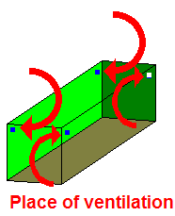Check Rubber seal of door. If the rubber is broken, call manager to get other good container.
  - Check inside of the container is DRY. If you find wet nature in inside, call manager to get good dry container.
  - CLOSE ALL Ventilations of the container completely. Put sticky tape on the ventilations. If we missed this, dry bags will puncture

Ventilation windows are placed on corners of inside of container.
2 or 4 ventilations in a container. Close all ventilation windows.

  - 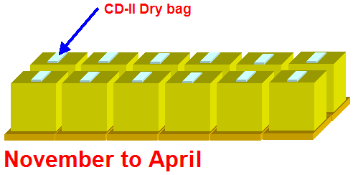 Put dry bags as figures. (Do not use damaged or already jelled)
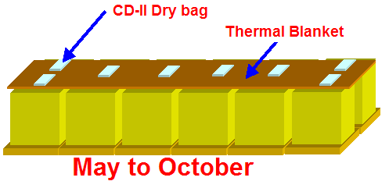
Season | 20ft container | 40 ft container
May to October | 8 sachets | 11 sachets
November to April | 12 sachets | 24 sachets
This shows qty and condition for voyage from Southern hemisphere to Northern hemisphere.

